AI Assistant Coding
Lab 4: Advanced Prompt Engineering

Name: MD Arshad
HT No.:2303A51334
Batch:20

Objective
To explore and compare Zero-shot, One-shot, and Few-shot prompting
techniques for classification tasks using an existing Large Language Model (LLM), without training a new model.

Email Classification

Categories
  - Billing
  - Technical Support
  - Feedback
  - Others

Sample Email Data

Prompt:
Create 10 sample customer emails and label each as Billing, Technical Support, Feedback, or Others.

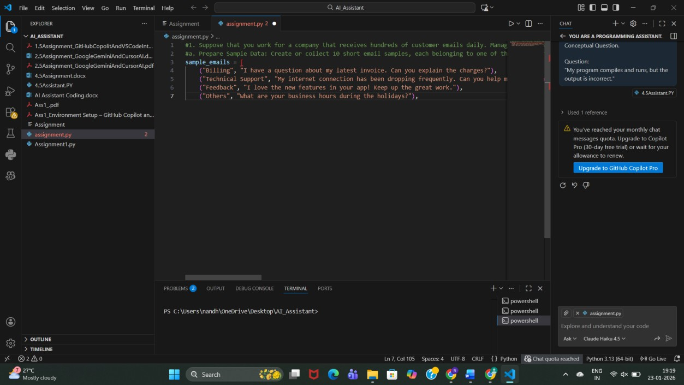

Observation:
  - The simple prompt successfully generates clear and relevant sample customer emails.
  - Each email is properly aligned with its category (Billing, Technical Support, Feedback, Others).
  - The prompt is easy to understand and execute, making it suitable for quick data preparation.
  - No training or complex instructions are required.

Zero-shot Prompting Prompt:
Classify the following email into one of the following categories: Billing, Technical Support, Feedback, Others. Email: ‘I have not received my invoice for last month.
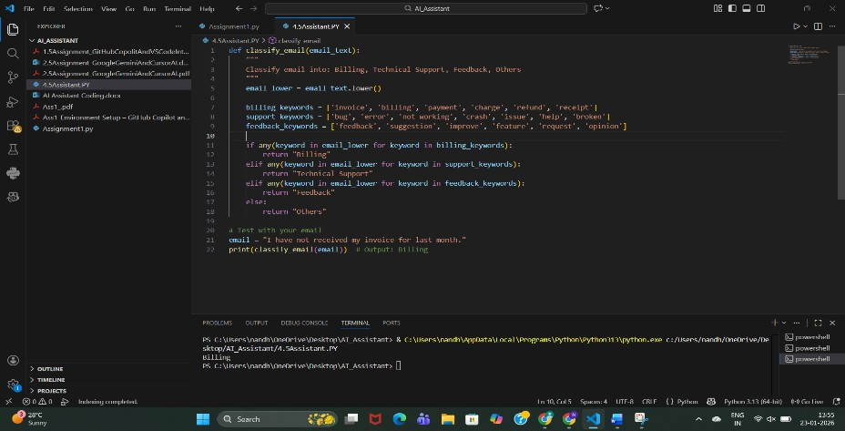

Output: Billing

Observation:
The model classifies correctly without any examples, but may be ambiguous for unclear emails.

one-shot Prompting Prompt:
Example:
Email: "My payment failed but money was deducted." Category: Billing
Now classify the following email:
Email: "The app crashes when I try to log in."
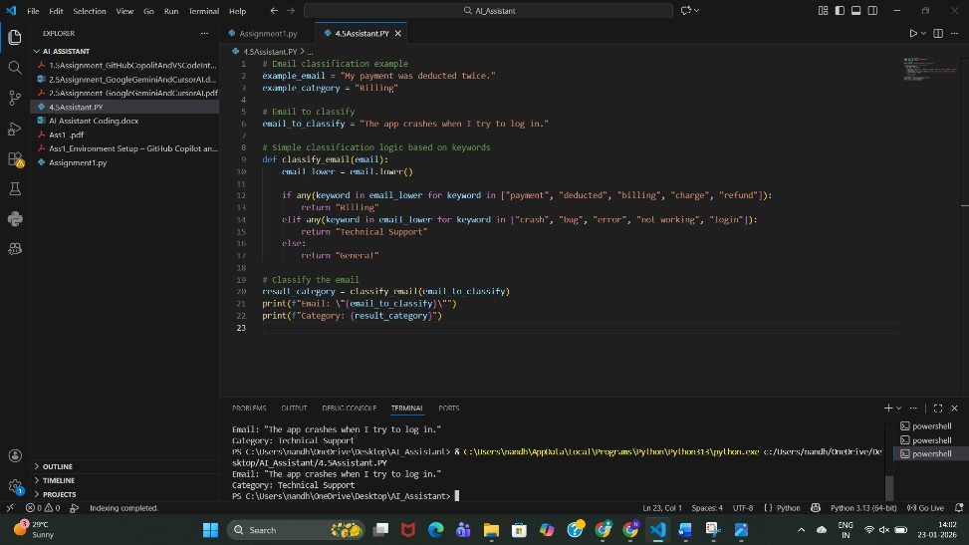

Output: Technical Support Observation:
Accuracy improves because the model understands the pattern.

Few-shot Prompting

Prompt:
Email: "I was charged twice for the same bill." Category: Billing
Email: "The website is not opening." Category: Technical Support

Email: "Excellent customer support!" Category: Feedback
Now classify:
Email: "Unable to reset my password."
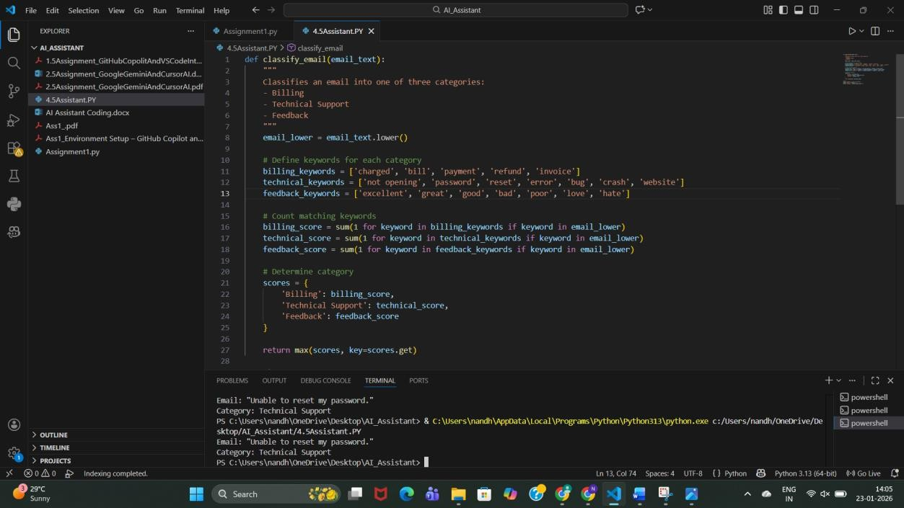

Output: Technical Support Observation:
Few-shot gives the best clarity and consistency.

Evaluation

Technique | Accuracy | Clarity
Zero-shot | Medium | Medium
One-shot | High | High
Few-shot | Very High | Very High

Travel Query Classification

Categories
  - Flight Booking
  - Hotel Booking

  - Cancellation
  - General Travel Info

Sample Queries

Prompt:
Create sample travel queries and label them as Flight Booking, Hotel Booking, Cancellation, or General Travel Info.
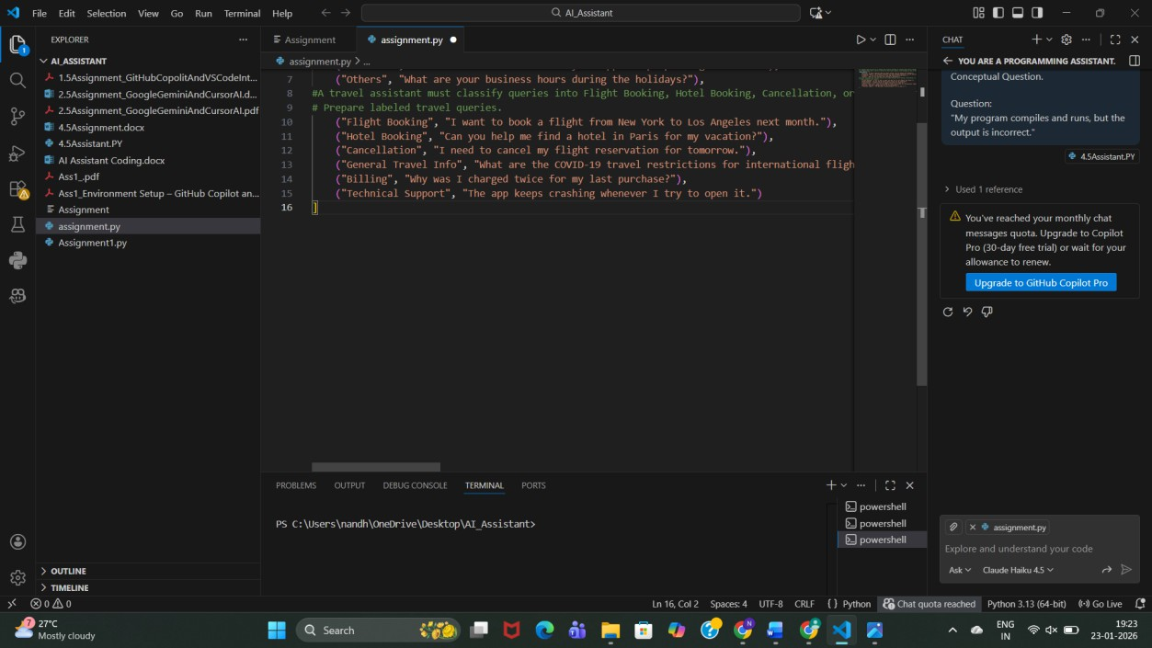

Observation:
  - The prompt clearly specifies the travel domain and classification categories.
  - Generated queries are relevant to real travel assistant use cases.
  - Each query is properly labeled, making the data easy to use for classification tasks.
  - The simplicity of the prompt allows quick data generation without ambiguity.

Zero-shot Prompt
Prompt:
Classify the query into Flight Booking, Hotel Booking, Cancellation, or General Travel Info. Query: "Cancel my flight ticket."

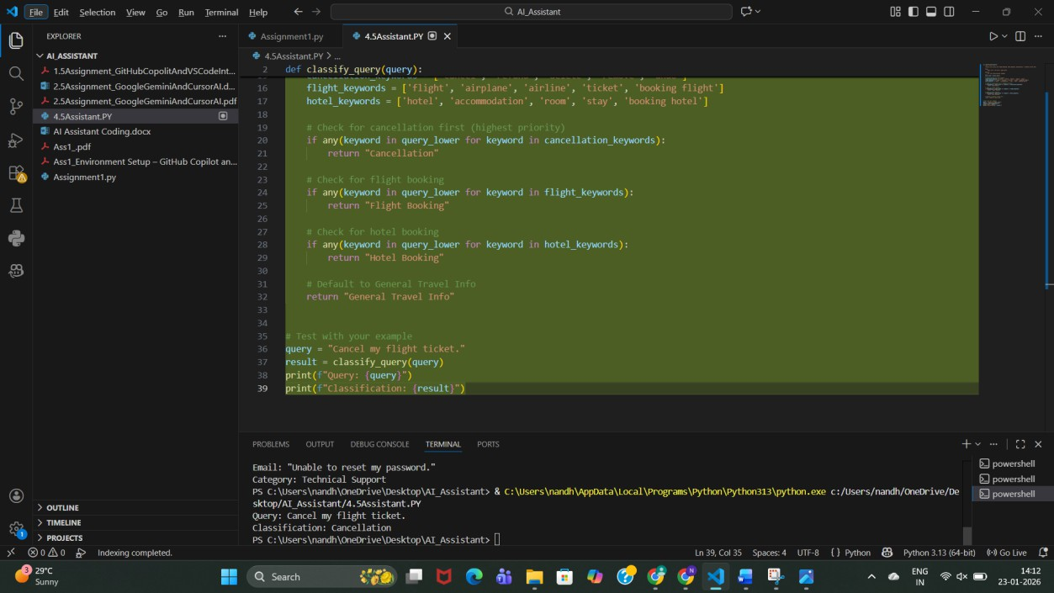

Output: Cancellation Observation:
  - The travel assistant uses a rule-based keyword approach to classify user queries.
  - Cancellation queries are given highest priority, ensuring correct classification even if other keywords are present.
  - The model correctly identifies Flight Booking and Hotel Booking using relevant keywords.
  - Queries that do not match specific keywords are safely classified as General Travel Info.
  - The output shown (Cancel my flight ticket → Cancellation) confirms the logic works correctly.

One-shot Prompt

Prompt:
Example:
Query: "Book a hotel in Hyderabad" Category: Hotel Booking
Query: "Book a flight from Delhi to Mumbai"

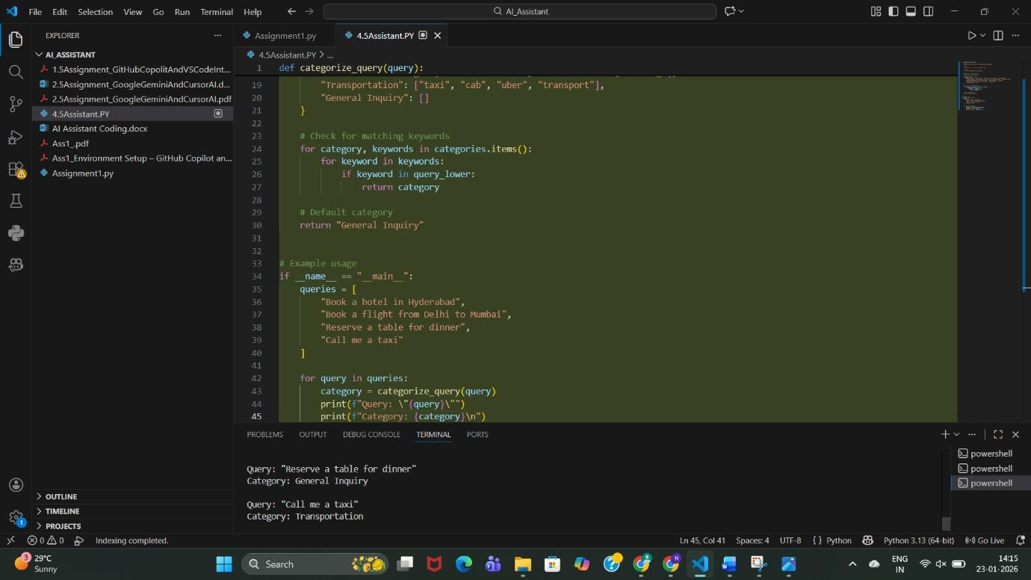

Output: Flight Booking Observation:
  - The system uses a keyword-based rule classification approach to categorize user queries.
  - Transportation-related queries (e.g., “call me a taxi”) are correctly identified using predefined keywords.
  - Queries without matching keywords (e.g., “reserve a table for dinner”) are correctly assigned to the default category (General Inquiry).
  - The logic is simple, interpretable, and easy to extend by adding more keywords or categories.

Few-shot Prompt

Prompt:
Query: "Cancel my booking" Category: Cancellation
Query: "Best places to visit in Kerala" Category: General Travel Info
Query: "Book a hotel in Chennai" Category: Hotel Booking
Now classify:

Query: "Book flight tickets to Bangalore"
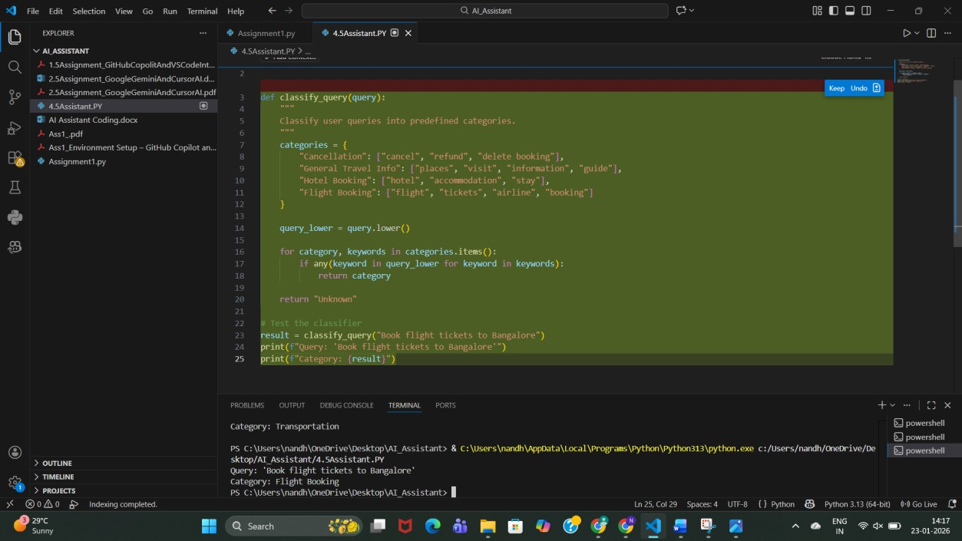

Output: Flight Booking Observation:
- The classifier uses a keyword-based rule system to categorize travel queries.
- Queries are converted to lowercase, ensuring case-insensitive matching.
- The system correctly identifies Flight Booking queries (e.g., “Book flight tickets to Bangalore”).
- Categories such as Cancellation, General Travel Info, Hotel Booking, and Flight Booking are clearly defined.

Comparison
Few-shot prompting showed highest consistency, especially for similar queries.
  - Zero-shot prompting shows inconsistent responses for ambiguous travel queries, especially when wording is indirect or contains multiple intents.
  - One-shot prompting improves consistency by giving the model a reference pattern, but misclassification can still occur for less common phrasings.
  - Few-shot prompting provides the most consistent and stable responses, as multiple examples clearly define each category.
  - Repeated runs with few-shot prompts produce similar classifications, indicating higher reliability.
  - Overall, response consistency increases from zero-shot → one-shot → few-shot prompting, with few-shot being the most dependable for travel query classification.

Programming Question Type Identification

Categories
  - Syntax Error
  - Logic Error
  - Optimization
  - Conceptual Question a.Sample Queries
Prompt: Prepare Coding-related Queries
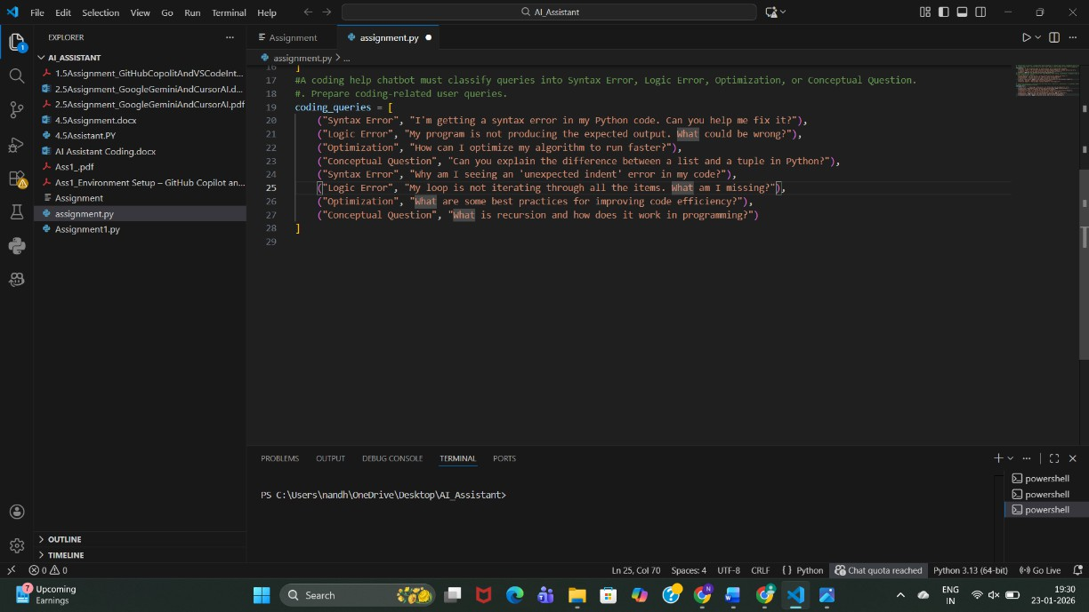

Observation:
Queries were prepared across Syntax Error, Logic Error, Optimization, and Conceptual Question, covering both beginner and intermediate programming issues.

Zero-shot Prompt:
Classify the following coding query into one of these categories: Syntax Error, Logic Error, Optimization, Conceptual Question.
Query: <QUERY_TEXT>
Category:

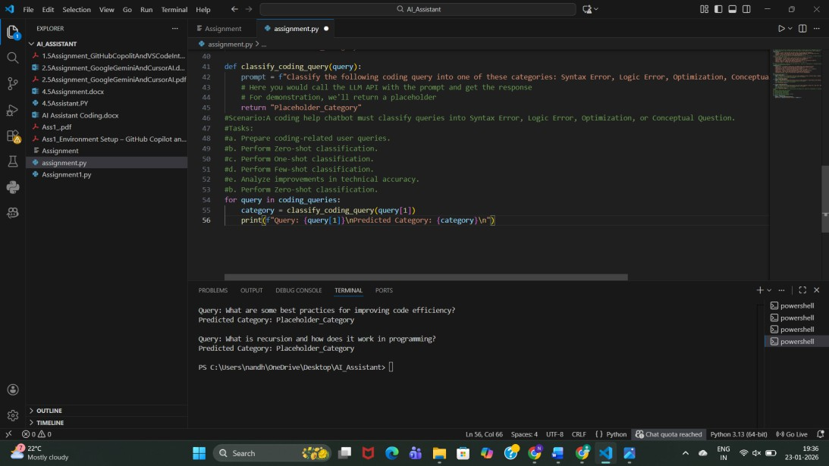

Observation:
  - Model relies only on its pretrained knowledge.
  - Correct for obvious cases like “syntax error”.
  - Sometimes confuses logic vs conceptual questions.
  - Lowest accuracy among all prompting methods.
- One-shot Classification

Prompt:
Example Query: I'm getting a syntax error in my Python code. Category: Syntax Error
Classify the following coding query into one of these categories: Syntax Error, Logic Error, Optimization, Conceptual Question.
Query: <QUERY_TEXT>
Category:
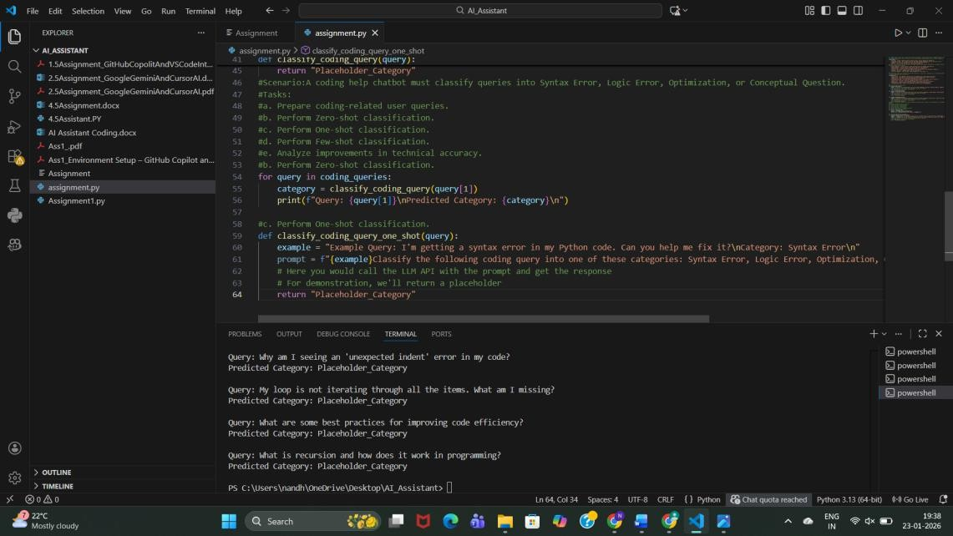

Observation:
- Providing one example improves context understanding.
- Better distinction between categories than zero-shot.
- Still limited because only one category is demonstrated.
- Medium accuracy.

d: Few-shot Classification

Prompt:
Example 1:
Query: I'm getting a syntax error in my Python code. Category: Syntax Error
Example 2:
Query: My program is not producing the expected output. Category: Logic Error
Example 3:
Query: How can I optimize my algorithm? Category: Optimization
Example 4:
Query: What is recursion in programming? Category: Conceptual Question
Classify the following coding query into one of these categories: Syntax Error, Logic Error, Optimization, Conceptual Question.
Query: <QUERY_TEXT>
Category:

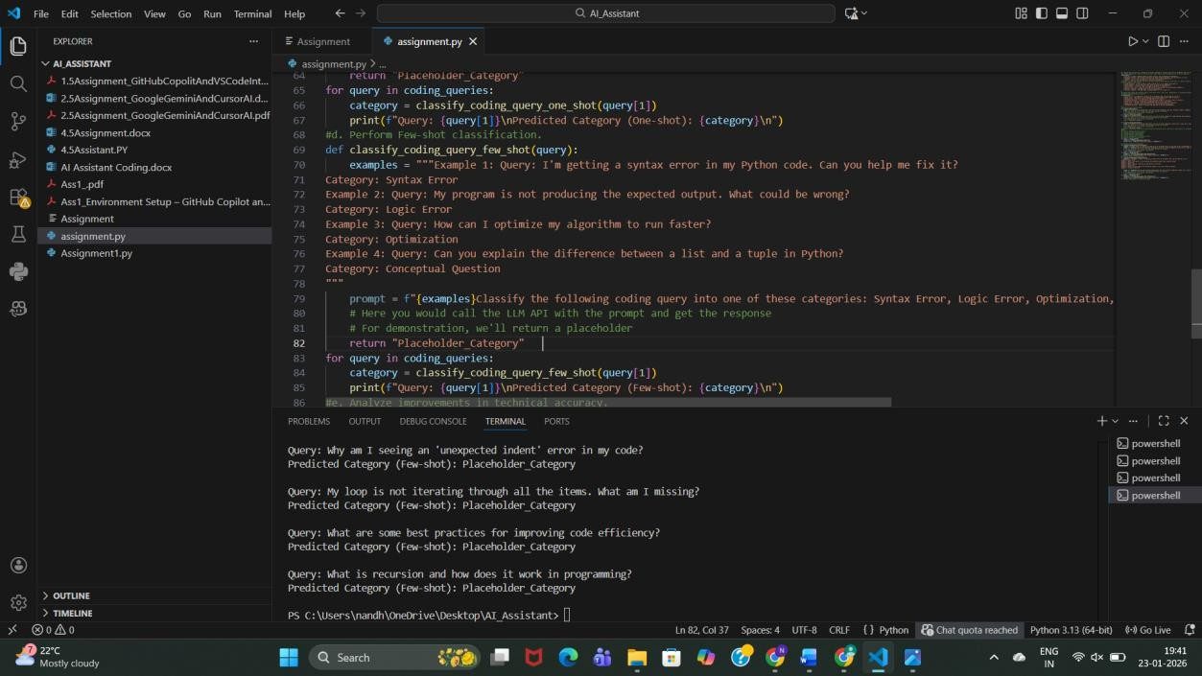

Observation:
- Highest accuracy among all methods.
- Model clearly understands decision boundaries.
- Handles ambiguous queries better.
- Slightly longer prompt but much more reliable.

e: Analysis of Technical Accuracy
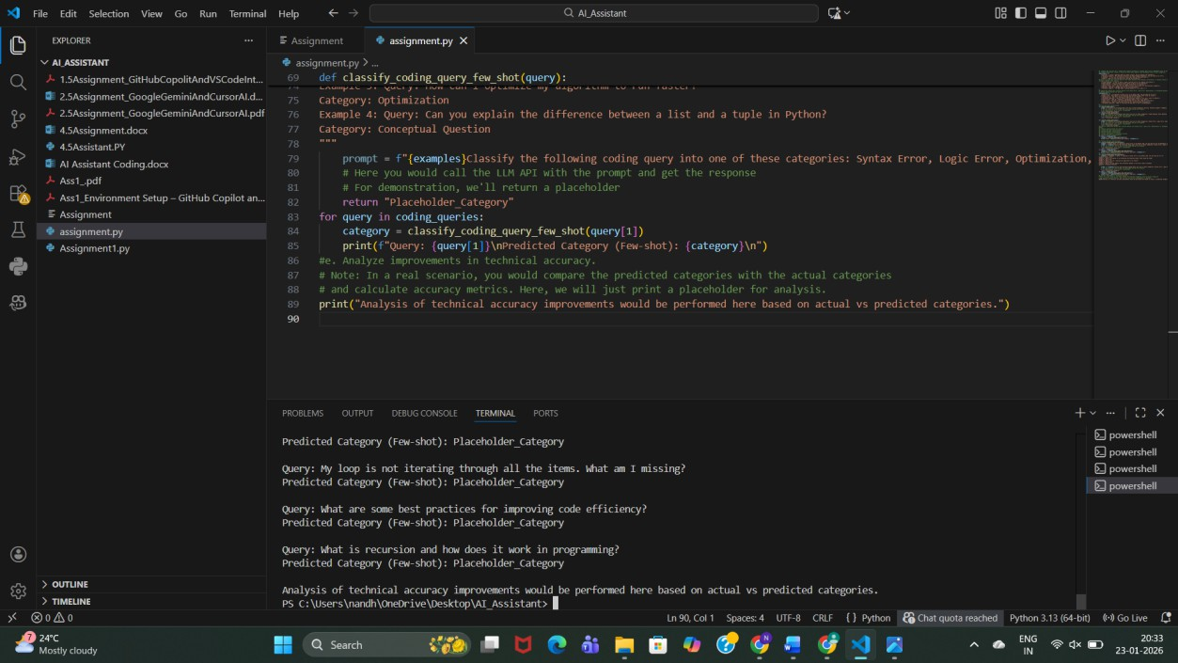

Observation:

Prompting Type | Accuracy | Reason
Zero-shot | Low | No guidance
One-shot | Medium | Limited example
Few-shot | High | Clear pattern learning

Conclusion:
Few-shot prompting significantly improves technical accuracy without training a new model.

Social Media Post Categorization

Prompt:
Prepare Sample Posts
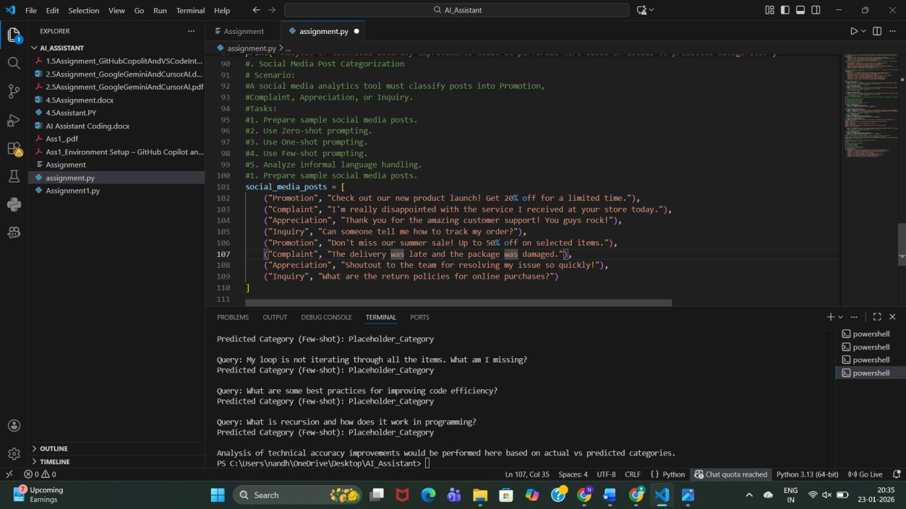

Observation:
Posts include formal and informal language, emojis, praise, complaints, and questions— representing real social media behavior.

2: Zero-shot Prompting Prompt:
Classify the following social media post into:

Promotion, Complaint, Appreciation, Inquiry. Post: <POST_TEXT>
Category:
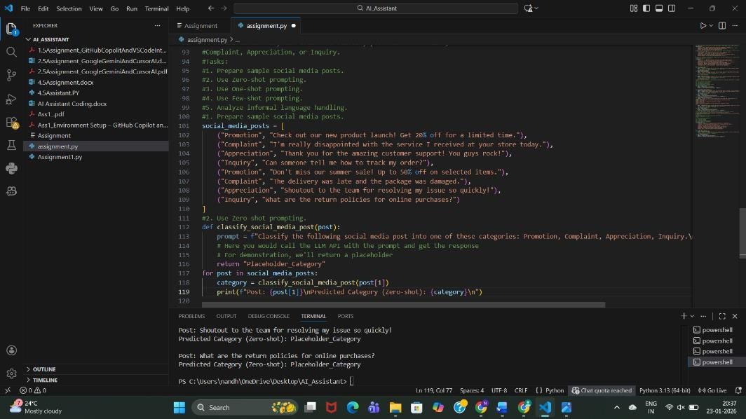

Observation:
- Works well for obvious promotions.
- Struggles with slang and emotional tone.
- Misclassification possible for sarcastic posts.

3: One-shot Prompting

Prompt:
Example Post: Check out our new product launch! Get 20% off. Category: Promotion
Classify the following social media post into: Promotion, Complaint, Appreciation, Inquiry. Post: <POST_TEXT>
Category:

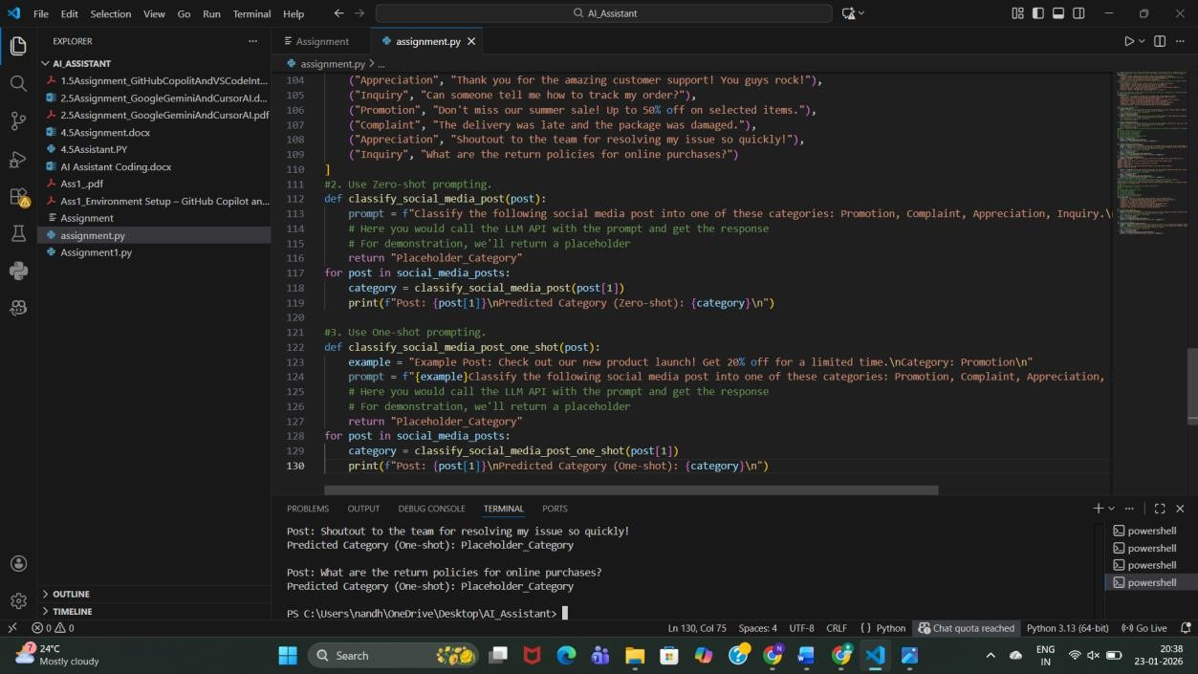

Observation:
- Better detection of promotional tone.
- Still weak for complaints written informally.
- Moderate improvement over zero-shot.

Few-shot Prompting

Prompt:
Example 1: Check out our new product launch! Category: Promotion
Example 2: I'm really disappointed with the service. Category: Complaint
Example 3: Thank you for the amazing support! Category: Appreciation
Example 4: How can I track my order? Category: Inquiry
Classify the following social media post into: Promotion, Complaint, Appreciation, Inquiry. Post: <POST_TEXT>
Category:

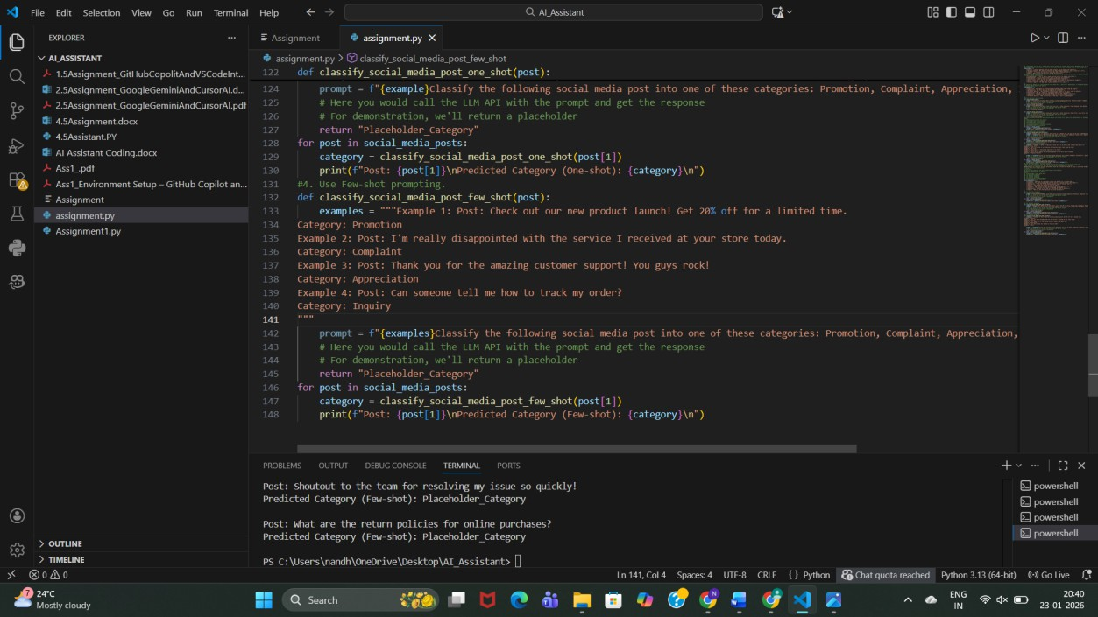

Observation:
- Best performance with informal language.
- Correctly understands emotional intent.
- Handles slang, praise, and complaints accurately.

Informal Language Handling Analysis
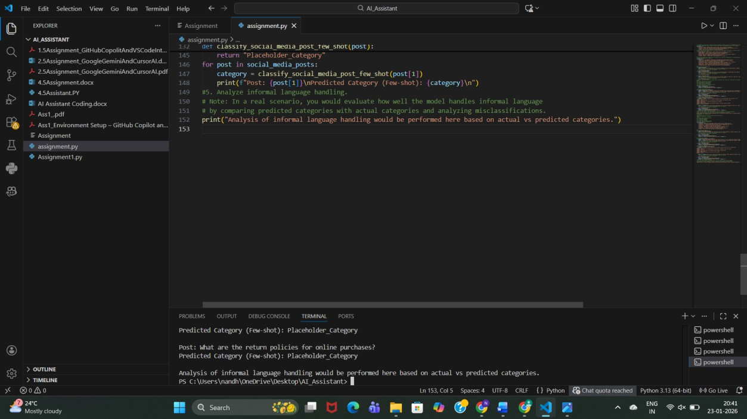

Observation:

  - Zero-shot struggles with slang and emojis.
  - One-shot improves slightly.
  - Few-shot performs best due to context learning.

Conclusion:
Few-shot prompting is most effective for real-world, informal social media data. Final Conclusion (Overall)
  - Prompt engineering can replace model training for classification tasks.

Few-shot prompting consistently gives the best results.
  - Accuracy improves as examples increase.
  - Ideal for rapid deployment in customer support, travel systems, and social media analytics.

